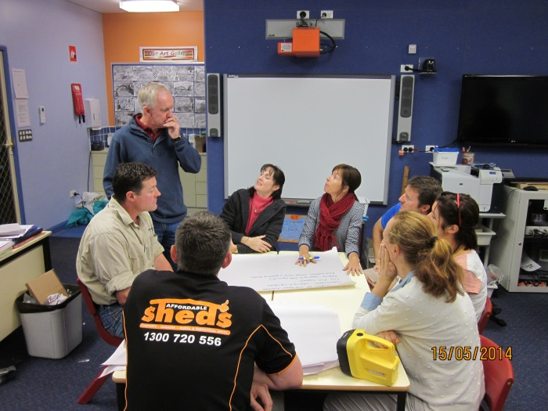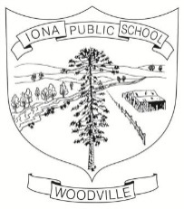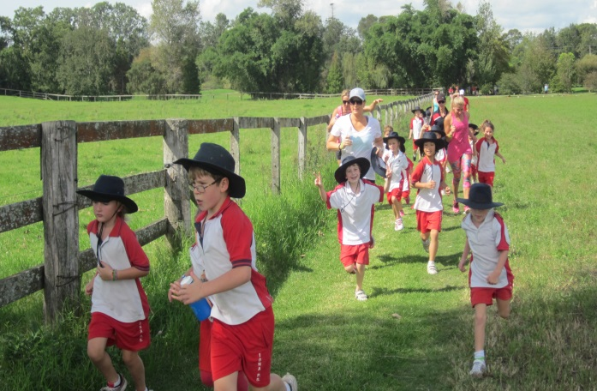

**2211**

Iona Public School

**Annual School Report 2014**

**[school code]**

School context statement

Our enrolment at the end of 2014 was 71, including 33 boys and 38 girls, the students being organised into three multi-stage classes. Our students are very happy and are extremely proud of their achievements. Their learning is guided by staff who are committed to excellence in teaching and who consider the individual needs of each student when implementing their quality learning programs.

Principal’s message

One hundred and sixty two years ago, the government of the day established a public school at Iona, named after the mystic island of Iona on the western coast of Scotland. The original Woodville Public School, was opened in 1850 before being changed to Iona Public School in 1853. During this time there have been many technological and educational changes. From being a single classroom with fixed seats and slates throughout its history, with school numbers fluctuating up to the 1980s, we now have a thriving school of 71 students, with a very supportive school community and modern facilities which ensure the successful education of Iona School students.

Today, the students experience a broad curriculum utilising interactive whiteboards, connected classroom facilities and modern computer technology. The world is now closer and more accessible for children as we prepare our students for life in our increasingly complex society. We are continually able to show that “Small Schools are Great Schools” with a consistent high level of achievement with National Testing (NAPLAN), successful sporting achievements, participation with dance in Starstruck and our continued focus with public speaking and debating, with one of our Year 5 students winning the Hunter Regional Final in Public Speaking this year. Parents and community, as partners in the education of their children, continue to be actively involved in daily school life and can be justifiably proud of their local school over its long history.

***Learning Together in Harmony****,* the words of our school motto, remind us of the spirit of our school community. This spirit which has seen our school be so successful will continue to guide our school into the future.

I certify that the information in this report is the result of a rigorous school self-evaluation process and is a balanced and genuine account of the school’s achievements and areas for development.

**Daryl Sheppard , Principal**

P & C and/or School Council message

***President*** – Mrs Lucy Anderberg

***Secretary*** – Mrs Melissa Bird

***Assistant Secretary:*** Mrs Michelle Hicks

***Treasurer*** – Mrs Nicole Crossland

***Assistant Treasurer***: Mrs Fiona Lawrence

***Vice President*** – Mr Pat Lannen

***Canteen Manager*** –Mrs Jo Dawson

***Uniform Co-ordinator*** – Mrs Michelle Hicks

2014 has again been a busy year for Iona P&C.

The P&C is a group of dedicated parents who assist our school in a variety of ways which include fundraising and assisting in the running of school activities like the school disco.

Without this contribution, our students would potentially miss out on activities and equipment that larger schools take for granted.

For example, the P&C subsidised costs associated with bus hire to transport students to swimming in Term 4 – this cost would otherwise need to be paid by parents.

Donations from the P&C will assist in the purchase of educational resources such as laptops and library resources. We are also seeking quotes for the purchase of a large storage shed for the school grounds. We also donated a sizable amount to the Woodville School of Arts for the upkeep of this hall. This is a great asset that the school uses free of charge and is our way of showing our appreciation.

The P&C achieved this by fundraising in the form of raffles, a pie drive and the running of canteens and BBQs at events like the Zone Cross Country and Election Day. Our major fundraiser was again the Horse Sports Day which raised thousands of dollars and was held in October. This all day event took months to organise and involved over 180 riders and horses from all over the region.

Throughout the year, members of the P&C had individually set aside their own time and researched grants from government and private organisations. Members of the P&C are actively involved in the School Council, have assisted in organising the School Disco and the running of the School Canteen.

I would personally like to thank the members of the P&C committee and anyone who assisted in various ways throughout the year.

I would like to give special mention to one of our members whose association with the school finished after 11 years of dedication to the P&C and the school in general. Melisa Smith has been an active member of Iona P&C since her eldest son Sam started here in July 2003. Since that time she held the position of president for a number of years as well as other executive positions. Melisa was also the Canteen Manager for many years.

Melisa’s commitment was not isolated to the P&C, she was always the first one to offer help at the school in various ways such as coaching the netball team, Star Struck, swimming carnivals and as many of our older parents will remember – car-pooling students to events when our school population was much smaller. Melisa’s dedication to and pride in Iona Public School is an example to everyone.

***Mr Pat Lannen 2014 President***

School Council Message

The Iona School Council for 2014 consisted of Mrs Cindy Lidbury, Mrs Kim Proctor, Mr Pat Lannen (P&C President) and Daryl Sheppard, our Principal.

The School Council met most terms where we discussed many ongoing issues such as: continuing our efforts with Port Stephens Council about the lack of parking space in front of the school, assessing and summarising the Annual School Report surveys, reviewing and conducting a survey about a School Chaplaincy Program, reviewing our Iona Public School Position Paper resulting from our Community Consultation Meeting held in Term 2, discussing planned events for the school throughout the year and continuing our discussions and review of our Enrolment Policy.The council also reviewed the Annual School Report and reported back to the P&C meetings all issues discussed so ongoing communication of School Council decisions was maintained.

Student Representative’s Message

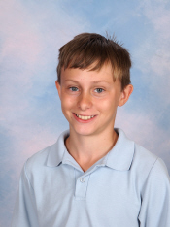 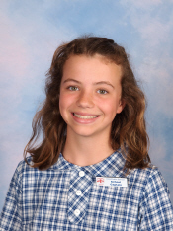 **Tom Bray Lucy Coren**

During the years we’ve been at Iona we have had many opportunities such as having music lessons, participating in a variety of sports and carnivals, school excursions such as camp, debating and public speaking, having leadership roles and during this year we have had the honour of being able to be school captains of this wonderful school.

We have made some special friends and have been taught by some inspiring teachers. Not only is this school a happy place to come to and learn but it is a welcoming and community based school.

This year as part of our Year Six gift we are putting money towards our new basketball hoop located on our multi-purpose court, with some money also going to a new iPod dock station.

Year Six has designed sculptures outside the word “Harmony,” made out of corrugated iron that has a symbol on it that is important to each of us. They will be located in the front garden.

We would like to thank Iona on behalf of Year 6 for all the opportunities we have had over the last seven years, really, Thank you.

**Lucinda Coren and Thomas Bray**

**School Captains, 2014**

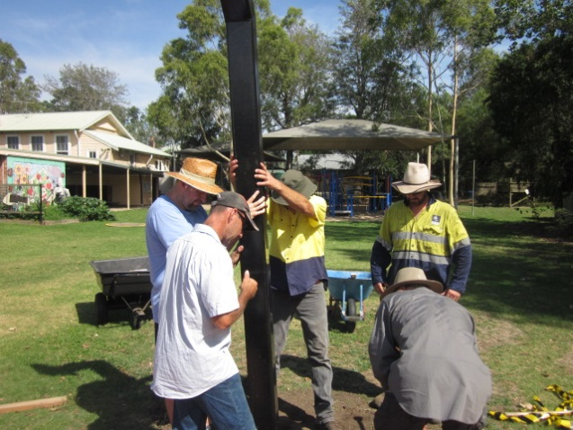

***Our parents installing the basketball post***

Student information

It is a requirement that the reporting of information for all students be consistent with privacy and personal information policies.

Student enrolment profile

|  |  |  |  |  |
| --- | --- | --- | --- | --- |
|  |  | |  | |
| **Gender** | | **2011** | | **2012** | | **2013** | **2014** |
| **Male** | | 26 | | 28 | | 32 | 33 |
| **Female** | | 39 | | 37 | | 37 | 38 |

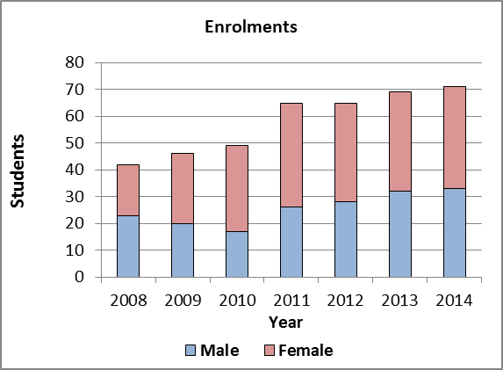

|  |  |  |  |  |
| --- | --- | --- | --- | --- |
|  |  |  |  |  |

Student attendance profile

|  |  |  |  |  |
| --- | --- | --- | --- | --- |
|  | **Year** | **2012** | **2013** | **2014** |
| **School** | K | 95.5 | 96.6 | 95.3 |
| 1 | 93.0 | 93.9 | 95.6 |
| 2 | 95.9 | 95.4 | 95.7 |
| 3 | 96.6 | 93.0 | 93.1 |
| 4 | 94.2 | 96.4 | 94.4 |
| 5 | 95.5 | 95.2 | 96.7 |
| 6 | 94.6 | 96.5 | 96.0 |
| **Total** | **94.9** | **95.3** | **95.2** |
| **State DEC** | K | 94.3 | 95.0 | 95.2 |
| 1 | 93.9 | 94.5 | 94.7 |
| 2 | 94.2 | 94.7 | 94.9 |
| 3 | 94.4 | 94.8 | 95.0 |
| 4 | 94.3 | 94.7 | 94.9 |
| 5 | 94.2 | 94.5 | 94.8 |
| 6 | 93.8 | 94.1 | 94.2 |
| **Total** | **94.2** | **94.7** | **94.8** |

Workforce information

It is a requirement that the reporting of information for all staff must be consistent with privacy and personal information policies.

The staff share a deep belief in the ability of every student to learn and to achieve high standards with appropriate and sensitive teaching in a quality learning environment.

In 2014 our teaching staff included Mrs Ashley Oates who was employed 3 days a week supporting student learning with individual programs and providing release to the Principal each day, and release time for all teachers.

Mr Sheppard taught 4/5/6; Ms Hamer 1/2/3 and Miss Bath K/1.

Apart from her class teaching, Ms Hamer also provided computer education and specific poetry teaching to 4/5/6. Mrs Oates relieved the teachers from class to perform programming and administrative duties, whilst ensuring Creative Arts, Space and Measurement, and Drug Education were a part of the whole learning experience. She also provided reading support programs to individual students. Throughout the year, Mrs Oates also took on the role as our L.A.S.T. (Learning and Support Teacher).

Workforce composition

|  |  |
| --- | --- |
| Position | Number |
| Principal | 1.0 |
| Deputy Principal(s) |  |
| Assistant Principal(s) |  |
| Classroom Teacher(s) | 2.6 |
| Learning and Support Teacher(s) | 0.1 |
| Teacher Librarian |  |
| School Counsellor | 0.1 |
| School Administrative & Support Staff | 1.2 |
| General Assistant | 0.2 |
| Total | 5.2 |

The Australian Education Regulation, 2014 requires schools to report on Aboriginal composition of their workforce.

We have no Aboriginal teachers currently employed at our school.

Teacher qualifications

All teaching staff meet the professional requirements for teaching in NSW public schools.

|  |  |
| --- | --- |
| Qualifications | % of staff |
| Degree or Diploma | 100 |
| Postgraduate |  |

Professional Learning and Teacher Accreditation

All teaching staff meet the professional requirements for teaching in NSW public schools, with 100% of the teaching staff holding degree, diploma or post graduate qualifications.

In 2014 all professional learning was focused according to our key areas for development: literacy and numeracy, ICT, quality teaching and career development. Staff participated in professional learning activities funded through the Tied Funds dissection and Teacher Professional Learning (TPL) funds, which form a dedicated component of our school’s global funding. Courses included workshops on: a two-day Primary Principal’s Conference; Musica Viva; Best Start (Early Learning assessment); the new National Curriculum; SAM-SAO Conference; and a Teaching Principal’s Conference.

School development Days each term were used by staff to: develop the School’s three year Management Plan for 2015-2017; review and anlayse the Naplan results; review the new Maths syllabus; participate in the Maitland Learning Community’s Maths workshops at Metford P.S. in July; update our compliance training with anaphylaxis, asthma, child protection and the Teacher’s Code of Conduct procedures; and reviewing class programming expectations and requirements.

Financial summary

This summary covers funds for operating costs and does not involve expenditure areas such as permanent salaries, building and major maintenance.

|  |  |
| --- | --- |
| Date of financial summary | 30/11/2014 |
| ***Income*** | $ |
| Balance brought forward | 70 579.56 |
| Global funds | 71 256.91 |
| Tied funds | 17 838.92 |
| School & community sources | 33 943.41 |
| Interest | 2 258.05 |
| Trust receipts | 2 258.05 |
| Canteen | 0.00 |
| Total income | 154 813.99 |
| ***Expenditure*** |  |
| Teaching & learning |  |
| Key learning areas | 18 373.83 |
| Excursions | 18 446.13 |
| Extracurricular dissections | 9 124.44 |
| Library | 3 205.29 |
| Training & development | 1 411.81 |
| Tied funds | 21 246.68 |
| Casual relief teachers | 11 736.22 |
| Administration & office | 18 578.62 |
| School-operated canteen | 0.00 |
| Utilities | 9 167.73 |
| Maintenance | 4 405.27 |
| Trust accounts | 27 308.01 |
| Capital programs | 0.00 |
| Total expenditure | 143 004.03 |
| **Balance carried forward** | 81 302.69 |
|  |  |

A full copy of the school’s 2014 financial statement is tabled at the annual general meetings of the School Council and/or the parent body. Further details concerning the statement can be obtained by contacting the school.

School performance 2014

Creative Arts

We provide many creative arts experiences, encouraging students to be actively involved, to share and to be proud of their achievements. Positive outcomes of our programs were demonstrated through:

* Our continued participation in the local Small Schools’ Debating Competition in Terms 3 and 4. Our team again did well, winning the “Valler Shield” for the fourth year running. Our students also competed in the NSW Multicultural Public Speaking Competition, the Hunter Regional Public Speaking Competition and the local Small Schools’ Public Speaking Competition held at Mt Kanwary P.S. One of our students, Asher, won the Regional Final for the Multicultural Public Speaking Competition, competing in the State Final, once again, in November.
* All students attending two Musica Viva concerts; and a variety of other shows such as: the Young Leader’s Day in Sydney in March; the Nick Earls talk in April; the Student Leadership Day for the Maitland Learning Community in May; Star Struck in June; NAIDOC Day celebrations at Ashtonfield in July; the Morris Gleitzman talk in August; two Musica Viva shows; the Life Education Van in September; the Riverlight Festival in Maitland in October; the Canberra four day excursion in September; the Pete the Sheep show at the Civic Theatre in October; the Iona Horse Sports Day in November; and the Maitland High School Music performance in November.

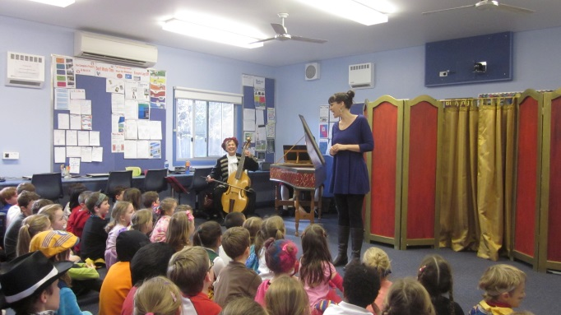

**Musica Viva performance**

* Our continued involvement with visiting shows including the Tony Bones Entertainment presentation in Term 3, focusing on the Younger Readers’ and Picture books of the year, supporting Book Week.
* A number of students being involved in drumming, guitar, keyboard and recorder lessons on a weekly basis, culminating in a musical recital for parents in Term 4;

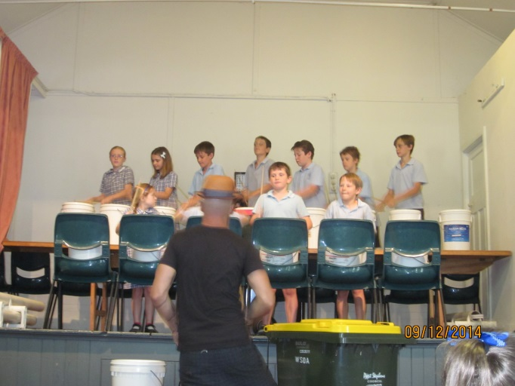

***Drumming group at our Musical Recital***

* The School Musical in December.
* Our Star Struck Group performing at the Newcastle Entertainment Centre in Term 2;

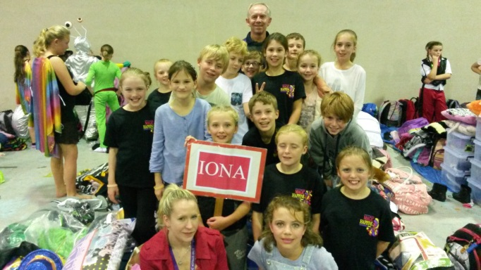

***Our Star Struck Troupe***

* All children being actively involved with our School Presentation Night in December;
* Our recorder group performing at the Sydney Opera House in August.; and
* The School Choir performing at many local events including the Riverlights Festival and our Annual Presentation Night.

Sport

Iona Public School students have always keenly participated in the schools’ comprehensive sporting programs, which are supported by our weekly fitness program. We again utilised the Raymond Terrace “Lakeside Centre” for our comprehensive swimming skills program, for 10 weeks in Term 4.

Our Horse Sports team represented the school beautifully throughout the year with many of our children winning ribbons at the Dungog, Merriwa, Singleton and Iona Horse Sports Days. We won the Iona Horse Sports Day trophy again this year.

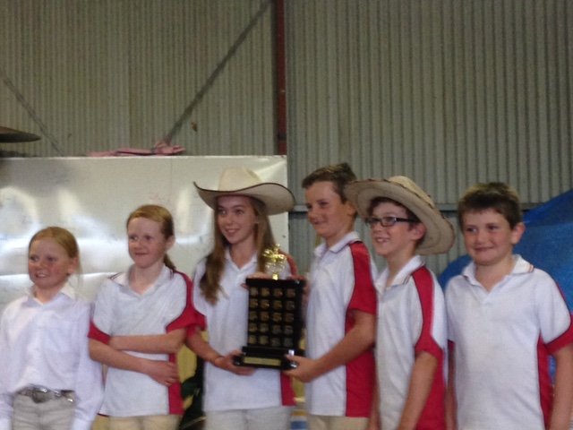

***Our Horse Sports Team holding the winning trophy at the Iona Horse Sports Day***

Our students also had the opportunity of participating in representative sport in Athletics, Swimming, Soccer, Netball and Softball. Our girls competed in the State Knockout Competition for netball and competed in the Singleton Netball Gala Day in Term 3; they reached the 4th round of the Girls State Softball Competition in August, playing their final game at the Mayfield Softball Centre; competed in the Boys Soccer Knockout Competition in Term 2 with one student competing in the NSW PSSA Athletics Championships, for High Jump, in Sydney in October.

Our students also enjoyed Dance sessions in Term 2 with Mr Szabo (one of our highly talented parents), a visit from the Newcastle Jets Ladies team, Jump Rope for Heart and the Stage 3 Gala Day in June.

**School Environmental Program**

We continued our weekly environmental group activities each week with all students involved with paper making, shredding, vegetable gardening and recycling. The senior students participated in a recycling program in Term 3, with all students again participating in the Schools Clean Up Day in Term 1. The Port Stephen’s “Solo Waste” also visited us in August. Four of our students also participated in the Williams River Catchment Crawl in May; with 4/5/6 participating in the World Environment Day activities, held at the Hunter Wetlands in June.

Our school also received valued support from the Port Stephens Council with an Environment grant of $300, which has been targeted for improving our forest area. We held a Working Bee in May where we cleared, planted and installed some bird boxes and a water feature in our forest area. We also supported the National Tree Day initiative in July.

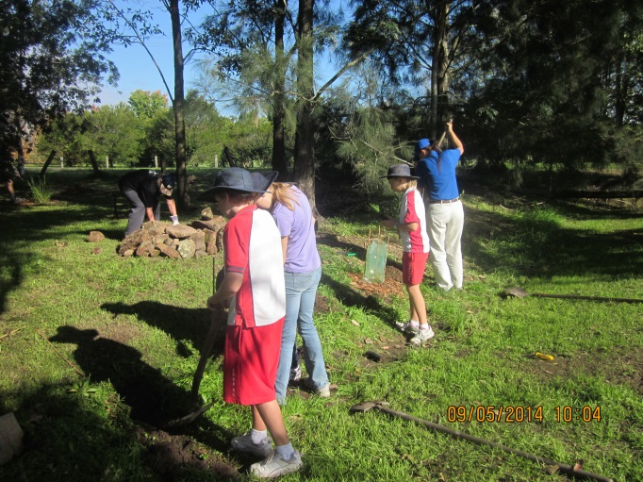

***Our Forest Working Bee in May***

**School Camps and Excursions**

Our school extends learning beyond the classroom by involving students in experiences which are associated with classroom teaching/ learning programs. Years 4/5/6 enjoyed a 4 day excursion to Canberra in Term 4.

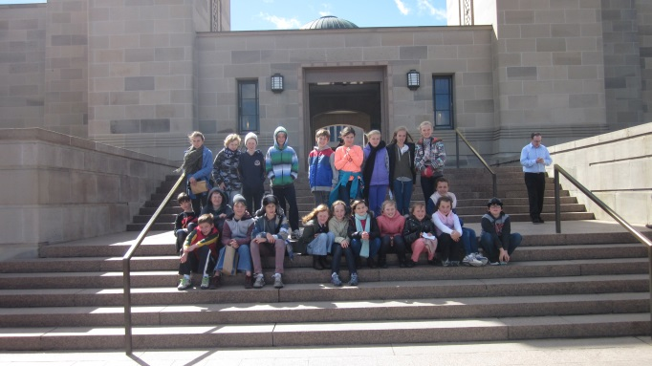

***Our students outside the War Memorial***

In Term 1, the Year 6 students attended the Young Leaders’ Day in Sydney.

All students also enjoyed their trip to the “Pete the Sheep” performance at the Civic Theatre in October.

Academic achievements

NAPLAN

In the National Assessment Program, the results across the Years 3, 5, 7 and 9 literacy and numeracy assessments are reported on a scale from Band 1 to Band 10.

The achievement scale represents increasing levels of skills and understandings demonstrated in these assessments.

Year 3: from Band 1 (lowest) to Band 6 (highest for Year 3)

Year 5: from Band 3 (lowest) to Band 8 (highest for Year 5)

The *My School* website provides detailed information and data for national literacy and numeracy testing (NAPLAN).

Click on the link <http://www.myschool.edu.au>

and enter the school name in the *Find a school* and select *GO* to access the school data.

NAPLAN Year 3 - Literacy (including Reading, Writing, Spelling and Grammar and Punctuation)

Our NAPLAN results for Year 3 are very pleasing with 83% of our students achieving in Bands 4, 5 or 6.

The average mean of our Year 3 students for literacy, which includes: reading, writing, spelling, grammar and punctuation, was 443.8 compared to the State average mean of 423.

In *Reading* the students achieved a 458.9 average mean score (State average 416.3). Although 78% of students were in the top two bands for reading, analysis of their answers reveals that they experienced difficulty in:

* directly locating information stated at the end of an information text.



In *Writing* the students achieved a 444.0 average mean score (State average 401.5). Although 89% of our students’ results were in Bands 4, 5 or 6, analysis of their answers reveals that they had difficulty:

* in demonstrating the use of some authoritative and technical words;
* with structuring texts in appropriate stages; and
* using correct basic punctuation.



In *Spelling* the students achieved a 448.9 average mean score (State average 418.8). Although the students answered most questions quite accurately, with 89% of results in Bands 4, 5 or 6, analysis of their answers reveals that they had difficulty:

* identifying words spelt using incorrect vowel combinations.



In *Grammar and Punctuation* the students achieved a 427.7 average mean score (State average 427.1). Although the students answered most questions quite accurately, with 78% of results in Bands 4, 5 or 6, analysis of their answers reveals that they had difficulty :

* with capitalisation of unfamiliar proper nouns;
* correctly punctuating lists; and
* identifying the reference for a pronoun in a complex sentence.



NAPLAN Year 3 - Numeracy

Although only 56% of our students’ Numeracy results were in Bands 4, 5 and 6, our average mean of 421.4 still compares favourably with the State average mean of 401.6. This means that the students who did well, achieved very highly.

Some areas our children had difficulty with in *Number, Patterns and Algebra* include:

* solving multi-step word problems; and
* using a number pattern to solve a problem.

In *Measurement, Data, Space and Geometry*, some students experienced difficulty in:

* identifying tally marks that model data; and
* using a scale to calculate distance.



NAPLAN Year 5 - Literacy (including Reading, Writing, Spelling and Grammar and Punctuation)

Our NAPLAN results for Year 5 are also very pleasing with 71% of our students’ results at or above Band 6.

The average mean of our Year 5 students for literacy, which includes: reading, writing, spelling, grammar and punctuation, was 519 compared to the State average mean of 492.9

In *Reading* the students achieved a 517.2 average mean score (State average 497.3), with 82% of our results in Bands 6, 7 and 8. Some areas for improvement include:

* inferring the purpose of a literary description in the first paragraph of a text; and
* following a word chain to identify reasons for characters’ actions.



In *Writing* the students achieved a 488.2 average mean score (State average 467), with 75% of the results being equal to or above the state average of Band 5. Some areas of improvement include:

* correctly structuring persuasive texts; and
* consistently writing correct simple and compound sentences.



In *Spelling* the students achieved a 538.7 average mean score (State average 502.7). Seventy five percent of our results were equal to or above the state average of Band 6. There was no consistent pattern to the spelling errors made by students.



In *Grammar and Punctuation* the students achieved a 532.2 average mean score (State average 504.7), with 75% of results equal to or better than the state average. Some areas for improvement include:

* correct identification and use of contractions.



NAPLAN Year 5 - Numeracy

In Numeracy, 82% of our Year 5 students scored results in Band 6 or above, with our mean score of 511.1 comparing very favourably with the State mean score of 488.5.

In *Data, Measurement, Space and Geometry*, some areas in which our students had difficulty include:

* recognising and identifying quarter turns made on objects; and
* recognising the shape resulting from cutting and folding a disk.

In *Number, Patterns and Algebra*, some students experienced difficulty with:

* multi-step word problems; and
* solving word problems involving ratios.



Other achievements

Significant programs and initiatives – Policy and equity funding

Aboriginal education

In classroom teaching/learning programs, Aboriginal Education is addressed in Human Society and Its Environment (HSIE), Science and Technology, English and Creative Arts learning activities. At all school assemblies and community functions, the original custodians of the land are acknowledged. In Term 2, we celebrated NAIDOC Day with Ashtonfield Public School, enjoying many traditional activities during the day at their school.

Multicultural education and anti-racism

Class teaching and learning programs, particularly through Human Society and Its Environment (HSIE), English and Creative Arts activities continue to emphasise the importance of cultural diversity and racial harmony within Australian society.

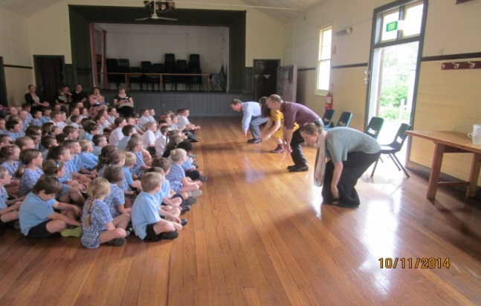

*The Musica Viva Show ”Song Company” in Term 4*

By involving our students in the *Musica Viva*  Performing Arts program, our students experienced music and dance from cultures different to their own.

Through our Connected Outcomes Units of work, our K/1 students examined the different groups that exist in our communities with their “I am Me” unit; our 1/2/3 students examined different cultures in the “Journeys” unit while our 4/5/6 students looked at the different groups in our society in the “Australia Grows to Nationhood” unit. Their participation with the CWA project focusing on Botswana further enhanced their understanding of our multi-cultural society.

We also engaged many school parents in our Harmony Day celebrations in Term 1. Our children enjoyed the Donna Jacobs show which focused on the theme of non-violence, conflict resolution, overcoming fear of difference, welcoming the stranger and developing the qualities that make for a noble character.

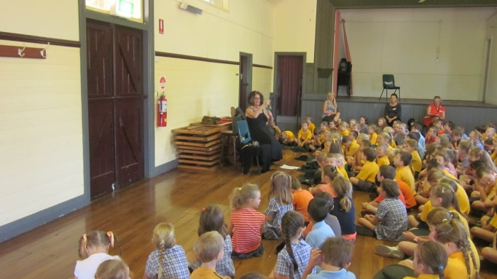

*The Donna Jacobs Show in Term 1*

Other Significant Initiatives

Kidspreneur Program

The Year 6 students participated in the Kidspreneur Program under the guidance of Mrs Murphy. This program has the following aims: give perspective on business and the value of money; have kids consider entrepreneurial endeavour as a career choice; develop business literacy; integrate and supplement standard learning objectives with our real-world experiential programs; provide safe and secure opportunities to practice business skills; embrace all learning styles; encourage creativity and experimentation; reward achievement; foster initiative, responsibility and learning from success and failure in the entrepreneurial journey; build motivation, confidence and resilience; and harness entrepreneurial spirit for social and environment good.

The students selected their business projects and worked through the process of making their product, promoting it and selling their product to the community, with their “profits” (the aim of all business ventures) going towards our African Aid project and their Year 6 gift. The students came up with the following businesses with their profits listed in brackets-- The Chocoloco Group ($207.05); the Happy Emotions Group (Cards) ($73.40) and the LGT Gardening Group ($71.70). We sincerely thank our whole school community for supporting our Kidspreneur Year 6 students with these projects, knowing that the profits were equally shared between our African Aids project and the Year 6 gift.

Student Leaders Programs/Community Involvement

During 2014, our School Leaders conducted Student Council meetings every 3 weeks; they planned and carried out the Disability Awareness Project; they enjoyed the Student Leadership Day at Tenambit P.S.; and participated in the Kidspreneur project (with Mrs Murphy) raising around $360 in profit for our Year 6 present and the African Aid Foundation.

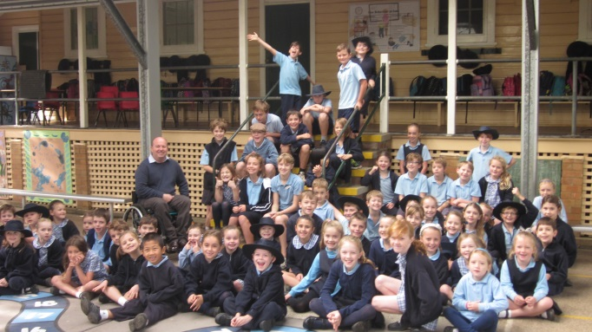

***Our Disability Awareness Day***

They also organised a variety of fundraising days such as:-Knights and Dames Day; a Talent Quest; Pikelet Day; Crazy Hair Day; Letter Day and the Dance Off in Term 1.

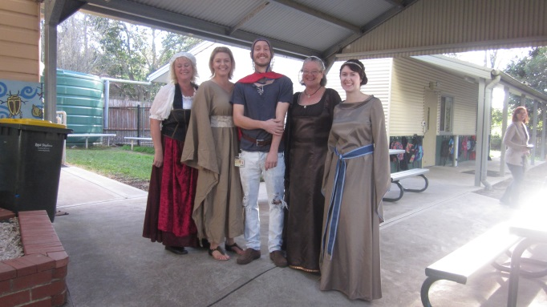

***Some of our staff dressed up for Knights and Dames Day***

Our School Community has been very involved with many school activities.

They include:-the Horse Sports Day; Grandparents Day; Easter Hat Parade; Canberra Excursion; School Disco; the Welcome BBQ; Forest Area Working Bee; the Basketball post working bee; the Amnesty International fundraiser; theBook Week Parade; and the unbelievable community support for our **much loved Christie Jones** earlier in the year.

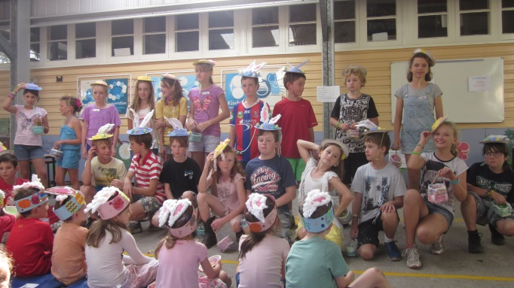

***Our Senior Students at the Easter Hat Parade***

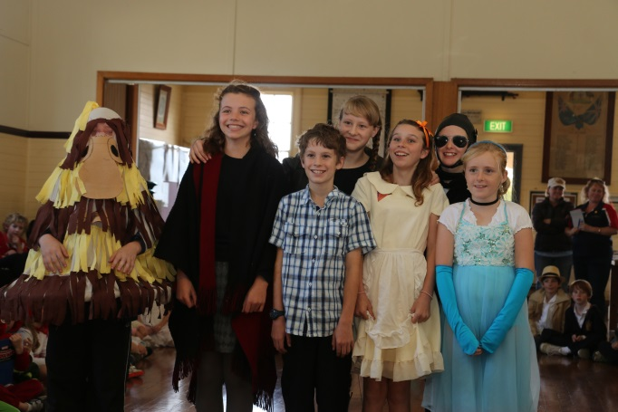

***Our Senior Students at the Book Week Parade***

School planning and evaluation 2012—2014

School evaluation processes

NSW public schools conduct evaluations to support the effective implementation of the school plan. In 2014 our school carried out an evaluation of Science and Technology.

**Curriculum**

**Science and Technology**

**Background**

Science and Technology was evaluated utilising a school developed survey asking questions about the importance of Science in the curriculum, the benefits of technology, access to computers and internet at home, computer skills, safety procedures, and future technology needs.

**Findings and conclusions**

32 per cent of families responded to the survey (generated by the staff) about Science and Technology. These surveys indicated all students enjoy Science and Technology lessons; Science lessons should be practical; they should be relevant to their future lives and generate an enquiring mind, leading to a broader general knowledge of the world in which we live. Our Technology survey revealed that most families have computers at home with internet access and they strongly believe that online safety and security is paramount.

**Future directions**

Science and Technology will continue to be a major focus in the future. We will ensure that Science and Technology is programmed and planned across all classes. We will investigate the possibility of developing a social media presence for the school, with Cyber-Safety lessons being incorporated into teaching and learning programs.

Parent Teacher Satisfaction

In May, 2014, a SWOT (Strengths, Weaknesses, Opportunities, Threats) Community Meeting was held at our school.

**Background**

The Iona Public School Community was invited to participate in a strategic planning workshop titled “Your Future Your Say” held on the 15th of May 2014. The purpose of the workshop was to articulate the values of the school community and the type of school it wants to see in the future. Thirty one parents and teachers attended the two hour workshop, with the following questions asked:- What makes our school unique? What are the strengths of the school? What are our weaknesses? What are our opportunities? What are our threats? What is the thing you value most about the school?

**Findings and Conclusions**

As a result of this community meeting, the following opportunities were considered most important when considering our future development: that we should support and embrace families from other cultures; we need to continue to be tolerant of differences in culture and religions; we need to continue our student involvement with extra curricula activities; we need to continue to involve the community at our school; we need to explore further opportunities with our School Environmental Program; our teachers need to continue to develop their professional knowledge; and we need to further enhance our school culture that creates well-rounded, empathetic, motivated, happy and educated students who will ultimately become functioning members of society.

**Future Directions**

Through our School Management Plan, we will target these opportunities and expectations, to further enhance the quality of education at our school, through the involvement and participation of our whole school community and the continuation of providing opportunities across all areas of the diverse curriculum.

Progress with School planning 2012-2014:

School priority 1

**Ninety per cent of students achieve Stage outcomes in Literacy:**

Evidence of achievement of outcomes in 2014:

Teacher Professional learning to include Focus on Reading (Stage 2 – Vocabulary); the various new curricula especially the new English and Maths syllabus; writing, quality teaching and the Australian Teaching Standards;

Reviewing Quality Teaching elements and engaging in an online module focusing on classroom practice;

Planning and implementing our new School English Policy, incorporating novel studies across the school in line with the new Science and HSIE Units of work;

Keeping abreast of the new Australian syllabus in English, Science and History by participating in many Adobe Connect Workshops, throughout the year, leading to the development of our School scope and sequences;

Continuing to review and plan our Learning Support needs through regular, five weekly, review meetings, each term throughout the year;

Reviewing our Naplan weaknesses, incorporating these identified skills in classroom programs, with particular improvement noted with inferential reading in Years 3 and 5 after participating in our Focus on Reading Program; and

Continuing our involvement with debating and public speaking, with many students successfully participating in these competitions. Our School Debating Team again won the local Small Schools Debating Competition and one of our students again won through to the State Final of the Multicultural Public Speaking Competition.

School priority 2

**Ninety per cent of students achieve Stage outcomes in Numeracy.**

Evidence of progress towards outcomes in 2014:

The further development of our school website with links to various numeracy programs;

Ensuring appropriate maths material was given for homework tasks;

Reviewing our Naplan weaknesses, incorporating these identified skills in classroom programs,

Incorporating quality teaching elements into all teaching programs, in particular GATS students;

Planning, trialing and finally implementing our Mathematics Scope and Sequence, across the school, in line with the new Australian Curriculum, utilizing the many Adobe Connect Workshops throughout the year, to increase teacher knowledge and expertise; and

Continuing our improvement of technology to support our numeracy curriculum.

School priority 3

**Ninety per cent of students achieve grade appropriate technology skills based on the school’s scope and sequence.**

Evidence of progress towards outcomes in 2014:

Participating in many Professional learning workshops and the use of online, connected classroom learning opportunities;

Initiating small group GATs activities for children with classroom focus on the provision of extension activities in class;

Evaluating and utilising the school scope and sequence to evaluate and educate skills to students across the grades; and

Examining the need for the use of Word Tablets, and planning for their introduction to our Learning Support Team’s programs in 2015.

**School priority 4**

**The whole school community is an integral part of each child’s educational, social and personal development.**

Evidence of progress towards outcomes in 2014:

Reviewing and upgrading our School PD/H/PE Policy;

Implementing our Live Life Well Policy developed last year;

Continuing our annual participation in the Life Education Program;

Actively participating in the Maitland Learning Community Leadership projects with our students, focusing on Disability whilst also initiating our participation in the Kidspreneur program, with Year 6, in Term 4;

Celebrating the NAIDOC week celebrations by participating with the Ashtonfield Public School’s celebrations and activities;

Continuing our annual involvement and celebration of Harmony Day;

Continuing our involvement with the African Aid Foundation initiative;

Being actively involved with all Maitland Learning Community initiatives; and

Continuing our support of all school organised events such as the annual Horse Sports Day.

Future Directions

2015-2017 School Plan

NSW DEC is implementing a new school planning process for 2015-17. The new plan will be published on the school’s website from the beginning of Term 2 2015.

We have targeted three areas for our new three year plan. They are: Quality Learning, Quality Relationships and Quality Systems.

We have developed the following **School Vision Statement:-**

*At Iona Public School, we place a high value on a culture that creates well-rounded, empathetic, motivated, happy and educated students-and ultimately members of society. The school community values an open, tolerant and harmonious environment where there is effective communication between all parties. This community also values the teaching of positive values, attitudes and behaviours to the students.*

We have also developed an explanation of our **School Context:-**

*Iona Public School is located in a rural area, where a close knit, supportive and inclusive school community is highly valued. This environment allows close interaction and involvement between skilled and educated teachers and the parent body. Our parents are interested and have the skills and education to make a positive contribution to the learning environment. The school community places a very high value on its rural location and outlook, and the small school size that enables a strong sense of community and involvement. There are currently 71 students who attend the school, with a growing number of nationalities now represented. The school is very committed to its involvement with the* [*Maitland Learning Community of Schools,*](http://www.maitland-lc.schools.nsw.edu.au/) *as well as providing a variety of extra curricula activities and sporting opportunities.*

About this report

In preparing this report, the self-evaluation committee has gathered information from evaluations conducted during the year and analysed other information about the school's practices and student learning outcomes. The self-evaluation committee and school planning committee have determined targets for the school's future development.

Mr Daryl Sheppard, Principal

Mrs Lucy Anderberg P&C President

Mrs Kim Proctor, School Council member.

Mrs Cindy Lidbury, School Council member

School contact information

Iona Public School

860 Paterson Road,

Woodville, NSW, 2321

Ph: 0249301415

Fax: 0249301807

Email: iona-p.school@det.nsw.edu.au

Web: www.iona-p.schools.nsw.edu.au

School Code: 2211

Parents can find more information about Annual School Reports, how to interpret information in the report and have the opportunity to provide feedback about the report at:

<http://www.schools.nsw.edu.au/learning/emsad/asr/index.php>