**[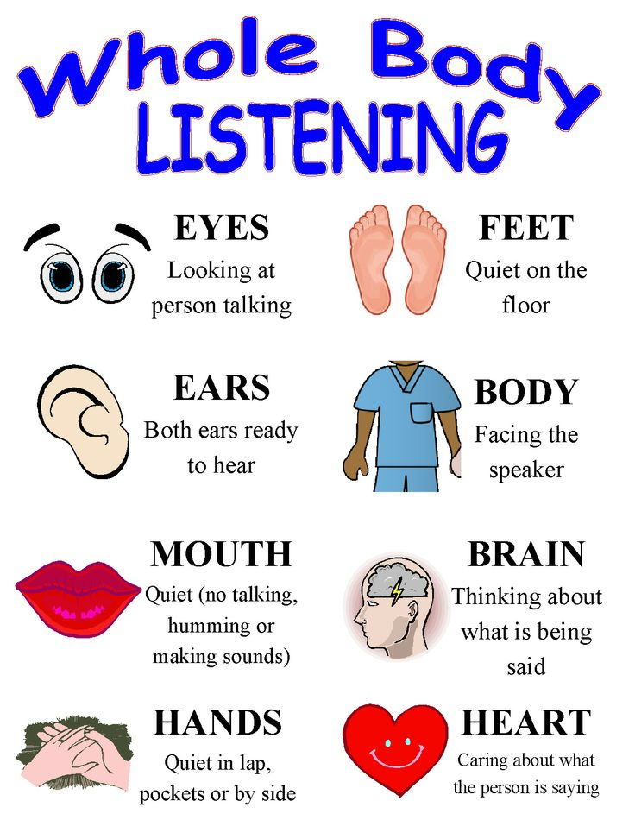](http://www.williambloom.com/writings/whole-body-listening-185.htm)**