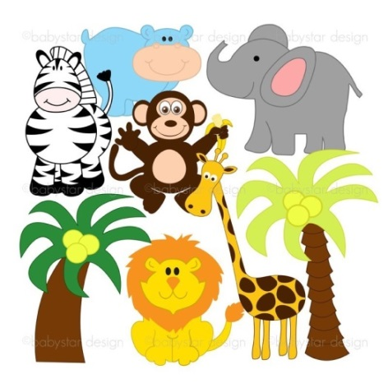**Stage 3**

**Homework – Term 1**

This term our Science Unit explores Biological Sciences and Living Things. To complement this unit students are asked to present a project to the class which investigates how the structural features and adaptations of animals help them survive in their own natural environment. Students will need to present a 2 minute speech to the class on their findings as well as handing in a hard copy of their project.

An adaptation is a feature that has evolved to help an animal survive and reproduce in its environment. Examples include monkeys (body design), giraffes (tongue shape), kangaroos (tail shape), owls (eye shape) seals/penguins (body fat) animals that camouflage and cassowaries (behaviour) This is just a short list, please do your research and find a very interesting animal!

Students are able to choose their own animal and may present their Information Report as they wish. For example, poster, PowerPoint presentation, ibook. Students will need to ensure that they include the following information.

* Name of animal and an image/s
* Description of animal
* Describes the environment to which the species is adapted
* Describes the structural features and behaviour of the animal.
* An explanation of the animal’s key adaptations (structural/behavioural) and how they help the animal survive in its environment.
* Any other interesting facts

C:\Users\rleary\AppData\Local\Microsoft\Windows\Temporary Internet Files\Content.IE5\BLOQ38KQ\smiley-faces-91[1].jpgA rubric is provided so that students understand the expectations of quality work and the marking guide for this report. **The project is due by Monday – Week 10 - 29 March** with class presentations presented through Week 11 on students’ speaking and listening day. Happy researching, I am really looking forward to seeing your reports!

Mrs Leary