|  |  |
| --- | --- |
| **Value: RESPONSIBILITY** | **Context: TOILETS** |
| **Expectation: I use my time wisely in the bathroom.** | |
| **Introduction:**  Begin the lesson by introducing the PBL expectation, “I use my time wisely in the bathroom.” Then have a discussion around the word wisely. Ask what the students think the word means. Then have a student look it up in the dictionary. | |
| **Discussion:**  Read a few scenarios to the class and discuss.  **Scenario 1:** Sam asks his teacher to go to the bathroom during class. On his way to the bathroom he sees his friend from another class, they stop and have a talk to each other and then decide to play on the equipment for a while. They then realise that they should be back in class and don’t go to the toilet but straight back to class. Is this using their time wisely?  **Scenario 2:** Christine is lined up to use the toilet after lunch with a lot of other girls, before the second bell rings. There are a lot of people that need to go to the toilet before the bell goes. When it is her turn she is very slow in the toilet area. She sees her friend’s shoes outside the door, so decides to bend down and say hi to her. They giggle and make a little game of it. The bell goes and there are still girls that need to use the toilet, but Christine gets to the silver seats before the second bell.  **Scenario 3:** Peter asks to go to the toilet during class. He walks straight down to the toilet area and goes in to the bathroom. He goes to the toilet and comes straight out when he is finished. He washes his hands and then walks straight back to class. On the way back he sees his friend Evie and says ‘hi’ as he walks past, but moves quickly back to class.  Ask what is wrong/right in each scenario. Refer back to the word wisely and how it relates to using the bathroom while at school. | |
| **Conclusion:**  Discuss ideas for how to remind students that they need to use their time wisely when in the bathroom. If time permits perhaps the students could design a sign to go on the inside of the toilet to remind everyone that they need to use their time wisely. It must be eye-catching and easy to read for everyone. Discuss where they could be displayed (inside toilet doors/near sinks etc.) | |
| **Resources:**  Blank A4 paper for posters | |
| **Evaluation:** | |

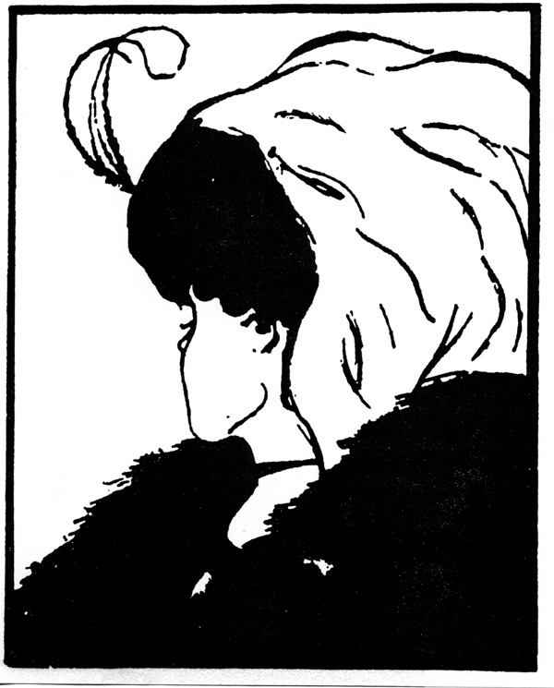

The story:

Once upon a time there were six blind men who all lived in the same town. One day the circus came to town and the men went to see the elephant. But how could they?  
The first man said, “We can feel him.”  
“That’s a great idea!” said the rest  
So each man went to feel the elephant.  
The first man touched the elephant’s big, flat ear. He felt it move slowly back and forth.  
“Oh” he said, “An elephant is like a giant fan!”  
The second man touched the elephant’s leg. “Oh, an elephant is like a tree!”  
The third man felt the tail and said, “No you are both wrong. The elephant is like a rope”   
But the fourth man disagreed. He felt the elephant’s pointed tusk and said, “Ouch! An elephant is like a spear”  
“No” said the fifth man, “Can’t you tell an elephant is like a wall.” He was feeling the elephant’s huge side.  
The sixth man grabbed hold of the elephant’s tusk. “You are all wrong! An elephant is like a snake!”  
The men continued to argue, each one certain he was right. It’s a fan” No a tree” Surely a rope” No, it’s a snake!” You’re wrong. I’m right!” Finally they got tired of shouting at each other and they all went home. So none of them ever found out what an elephant really was.

